ASSIGNMENT - 2

(

ASSIGNMENT TASKS)

NAME

PAARTH SHARMA

:

SECTION

CO29

2

:

ROLL NO

:

102103505

EMAIL

:

psharma1_be21@thapar.edu

SUBMITTED ON

:

16

th

September 2022

GROUP

:

2



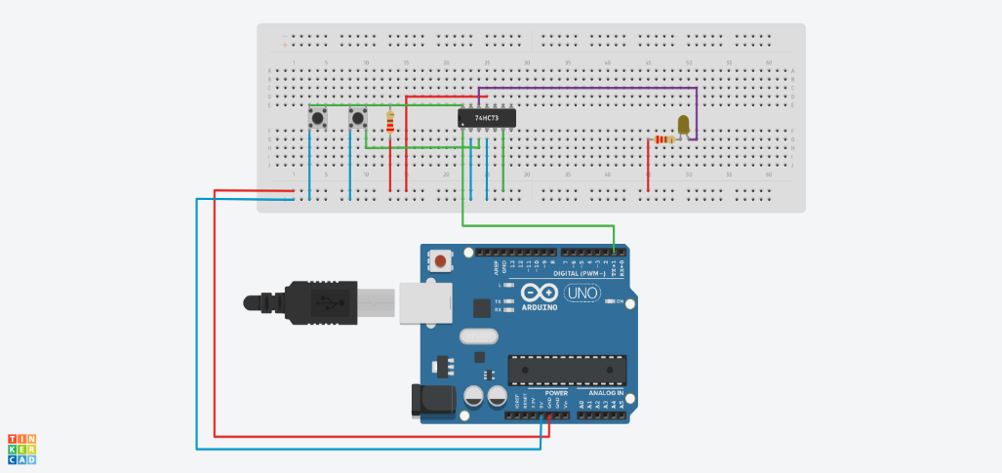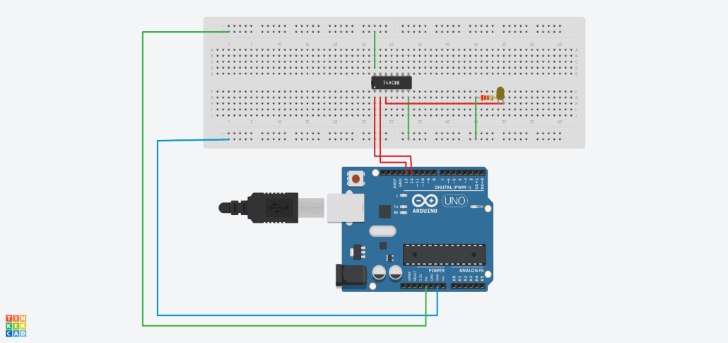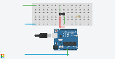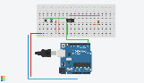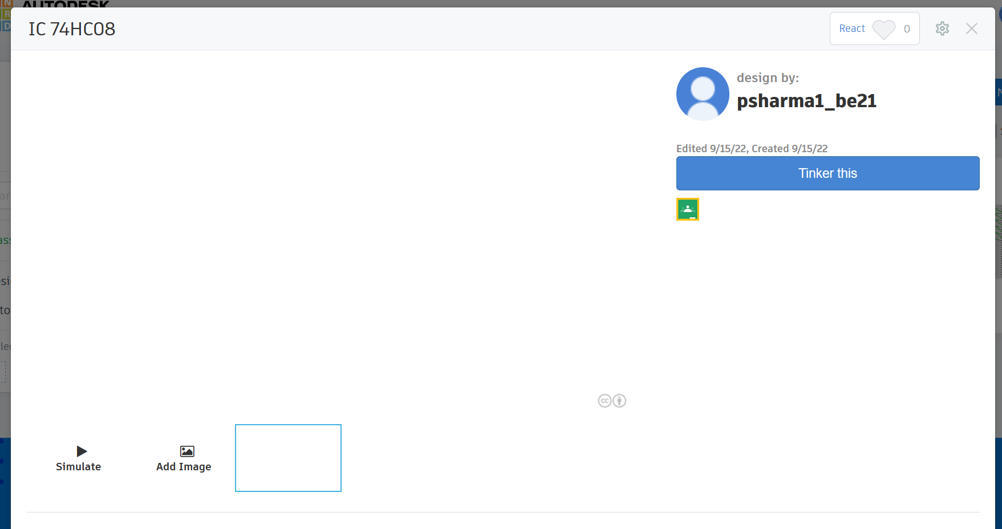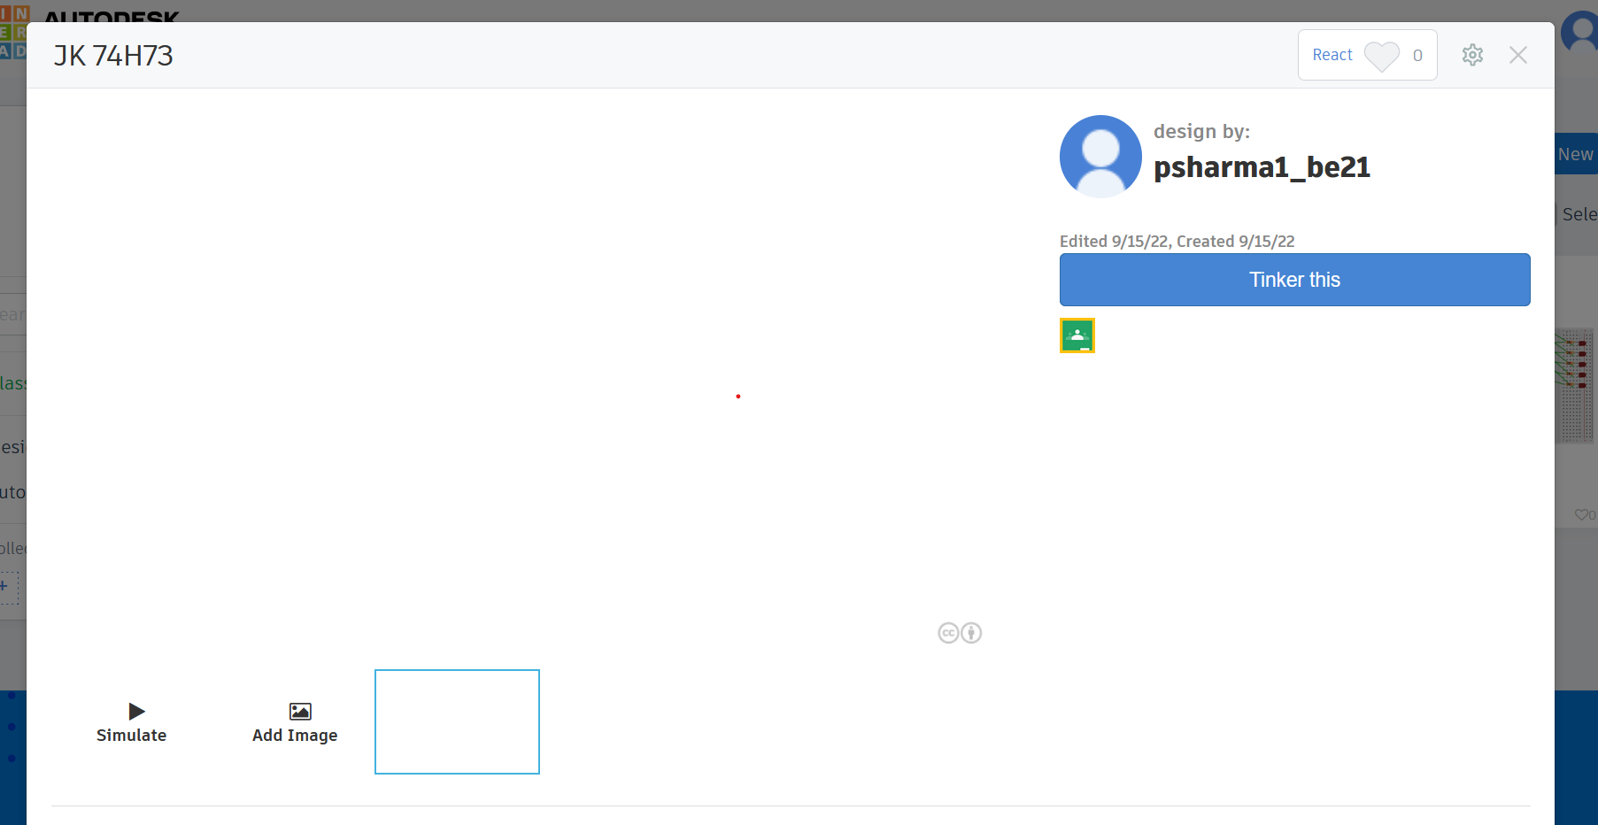

EXERCISE 2(C) – TINKERCAD

Q : Using Tinkercad, Illustrate the pin configuration and verify the truth table of

IC

74HC08 and IC 74HC73.

Solution :